Differentiation Reflection Exercises

- Peer tutoring and peer mentoring
Aim: to create a collaborative learning process and facilitate supportive relations between students (both same-age and cross-age)
Application: Appropriate for all primary grade levels, depending on the structure of the exercise

To Teach is to Learn Twice – Peer Learning and Students Collaboration on the Assignment
The students have as peers a big influence on each other’s learning. Learning is strengthened through a collaborative process, where relations between students in the classroom is the force that can create social inclusion and a desire to learn.
Peer learning is learning through interaction with peers and can be an effective method to foster social inclusion of newly arrived students.
1. Peer tutoring: Students teach each other
- Same-age tutoring: The students are in the same grade and one student teaches the other in a given topic e.g. in 10-15 minutes. The teaching student should have preparation time. It can also be that the two students receive an assignment each with the message that they shall teach each other, and that this cannot last more than 10 minutes per student.
- Cross-age tutoring: is when an experienced student teaches younger students. This can be through friendship-classes, where an older class teach a younger one.

2. Peer mentoring is when an experienced student supports a less experienced student in settling down, orient one self and obtain an increased level of well-being.
No matter which tutor approach is used, this way of teaching creates a stronger academic gain for all students as well as trust, knowledge and a positive interaction between students. An interaction that doesn’t just stop when the exercise is over, but that evolves and becomes a condition for community. This is the essence of social inclusion – that all students have and experience equal opportunities at the school.
Writing next is collaborative writing where the students work together to plan, write a draft, revise and edit their written work.

1. The student’s qualifications
Pre-understanding, knowledge about genres and writing, language, language use, grammatical skills and knowledge about layout.
2. Resource checklist
- Time
- Number of teachers: e.g. one teacher and one second language teacher
- Materials and aids e.g. model texts, writing templates, computer, paper, it-aids for dyslexics etc.
3. Targets for the students
- In relation to the curriculum, the year-plan for the subject and the students’ prerequisites and learning needs.
4. Composition of the groups
- The students work as writing-partners in the same-age tutor-groups, where they can challenge each other both academically and socially.
5. Implementation
- Let one student pick a model text (the teacher has a selection of good, authentic texts with an exemplary language use that the students can choose from)
- Let the writing-partner find out how this model text fits in the writing template (the class has a collection of writing templates, that all fits a genre – see example below)
- Let the writing-partners in collaboration find examples of language features in this type of text based on their knowledge about the genre. Here it might be relevant for the students to have access to an overview with genre features and examples.
- ‘Second language’ students need to see and hear teachers and tutors think out loud, find examples and apply concepts.

The tutor-pairs hereafter collaborate on:
- The interaction between the writer and reader: who is the writer? What role does the writer have (journalist, author, a 15-year old student?)? Who will read this? Who is the target group? Etc.
- Content: what is relevant? What do we know about it? Where can we find more information?
- Text structure: what framework fits this type of text? Which paragraphs should there be?
- Language use: how should the sentences be connected? Should it be present or past tense? How is should the sentences be constructed? Which words should be used – everyday words or words that signal knowledge and expertise?
- Layout, spelling, and punctuation: which construction should there be? This process should be divided into a before-, during- and after-phase, where you summarize and instruct; if convenient this can be done after each phase to make sure you follow the students’ work. It can also be a good idea to give the students the opportunity to see each other’s texts for inspiration and knowledge sharing. Finally, you can also write a joint model text with the students before they start writing themselves.

- Let them help each other in writing a finished text from a framework.
- When the students are done, another tutor-pair can give feedback based on the elements in the writing process.

- Lesson plan
Aim: to create a differentiated lesson plan constructed around the class dynamics and chosen subject area
Application: Appropriate for all primary grade levels when differentiated

Using the format on the next page as an example, create a differentiated lesson plan using your own classroom dynamics and preferred subject area.

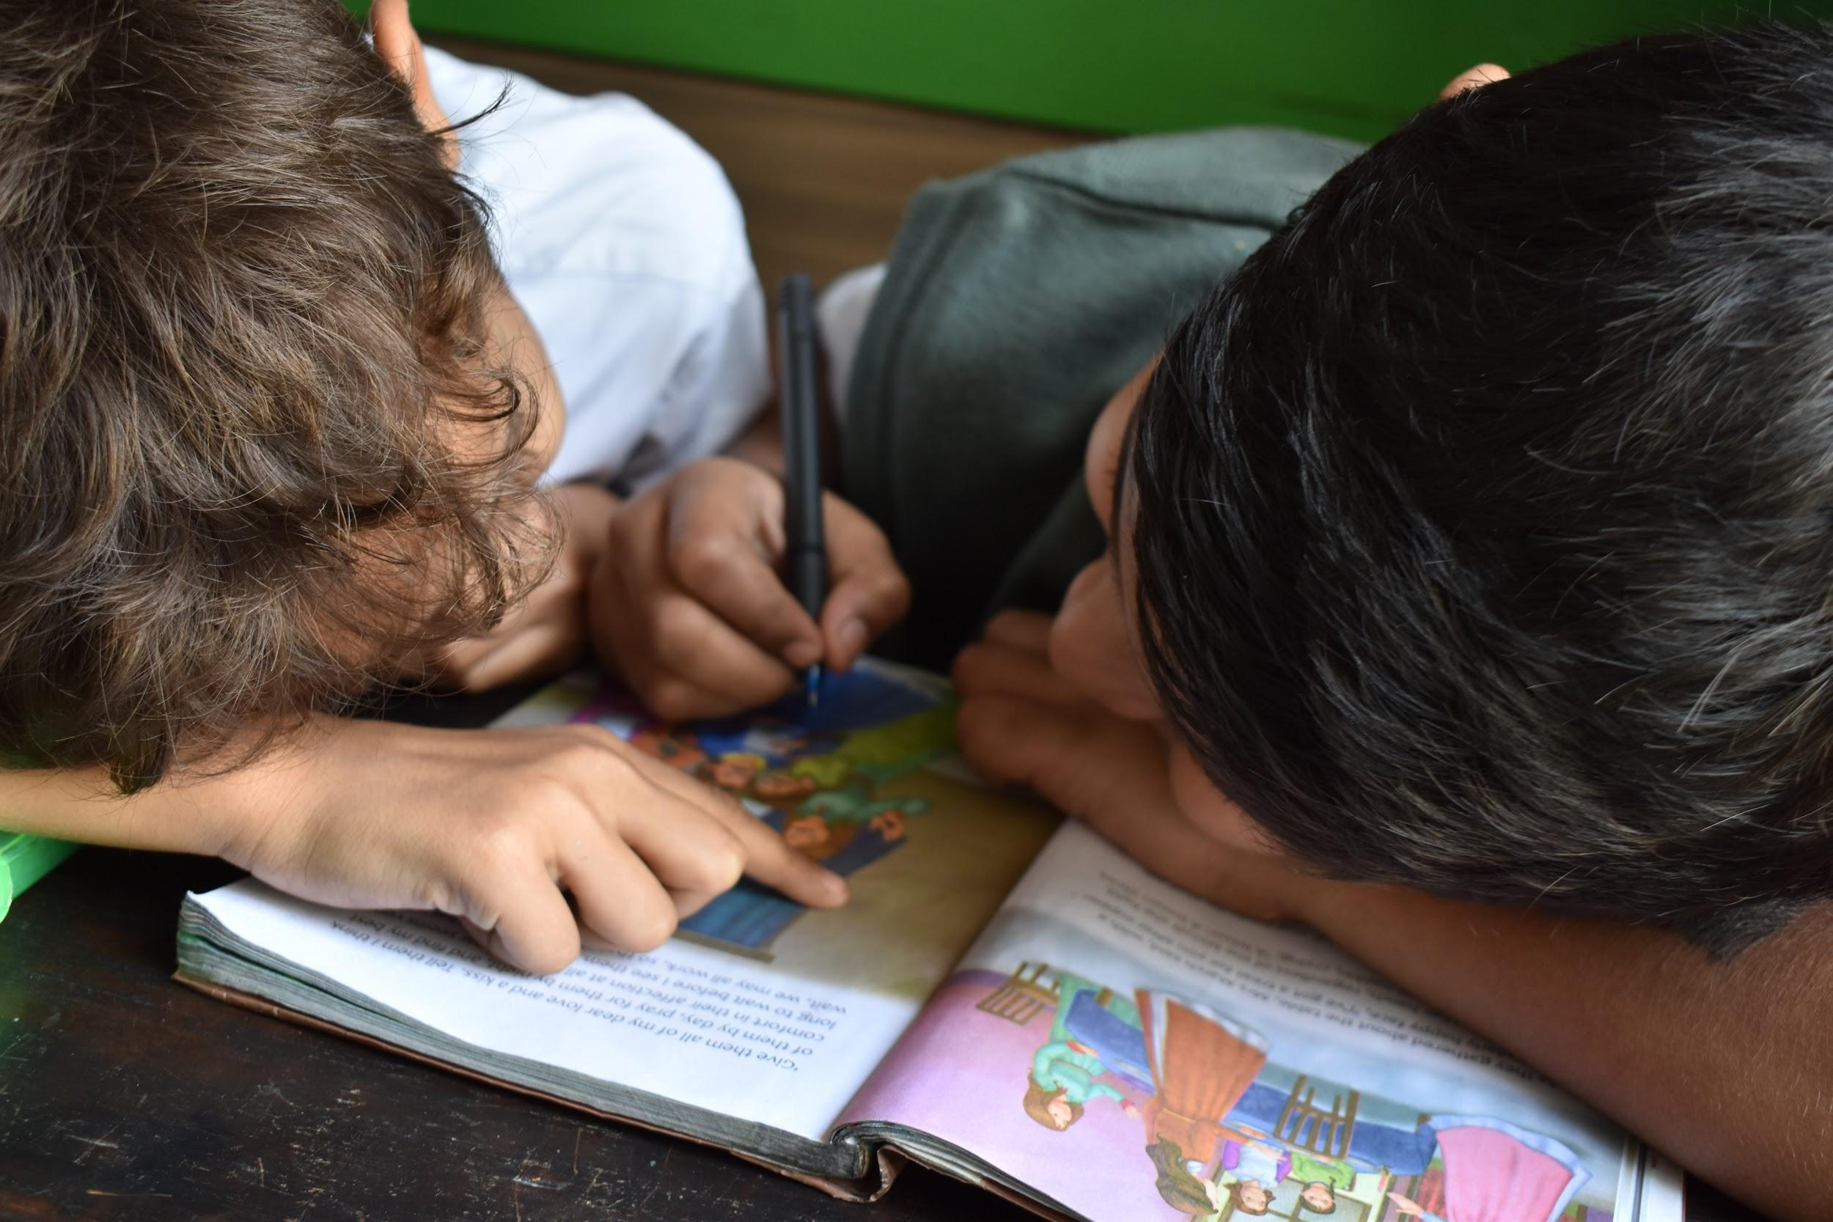
Unsplash, Andrew Ebrahim, Andrew Ebrahim@sdb_sjbc, https://unsplash.com/photos/zRwXf6PizEo

